# Comparison of Throughput

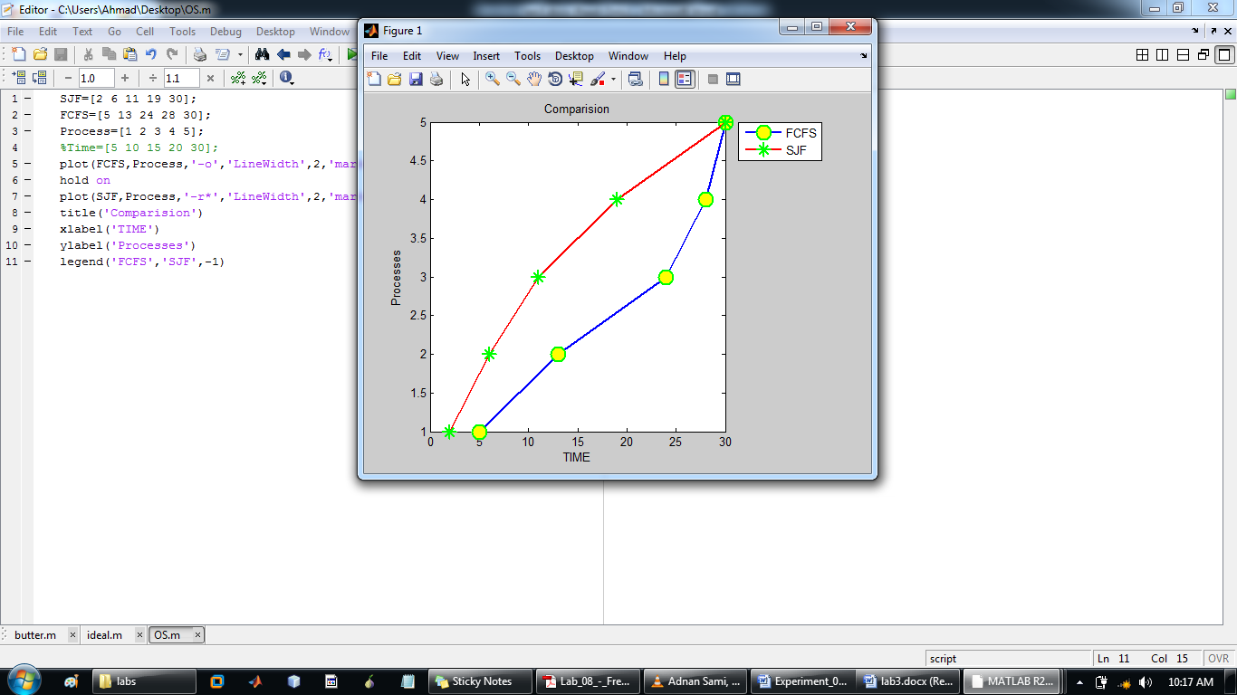

|  |  |  |  |  |  |
| --- | --- | --- | --- | --- | --- |
| **processes** | **P1** | **P2** | **P3** | **P4** | **P5** |
| **FCFS** | 5 | 13 | 24 | 28 | 30 |
| **SJF** | 2 | 6 | 11 | 19 | 30 |

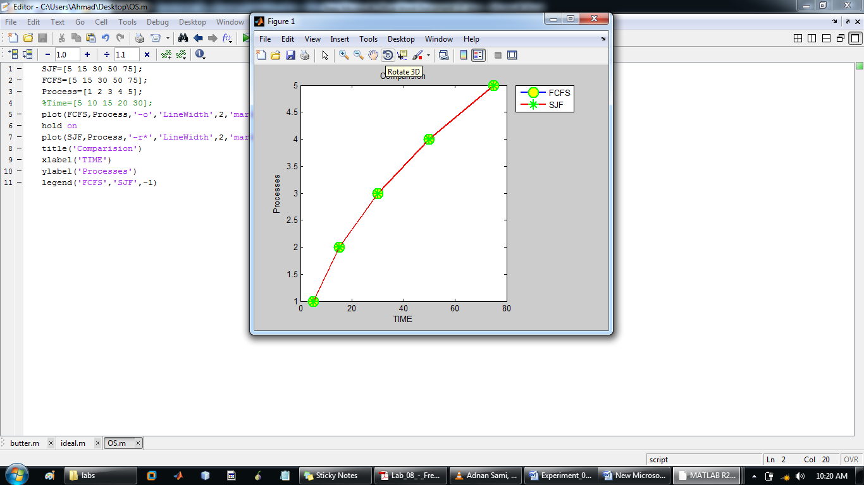

|  |  |  |  |  |  |
| --- | --- | --- | --- | --- | --- |
| **processes** | **P1** | **P2** | **P3** | **P4** | **P5** |
| **FCFS** | 5 | 15 | 30 | 50 | 75 |
| **SJF** | 5 | 15 | 30 | 50 | 75 |

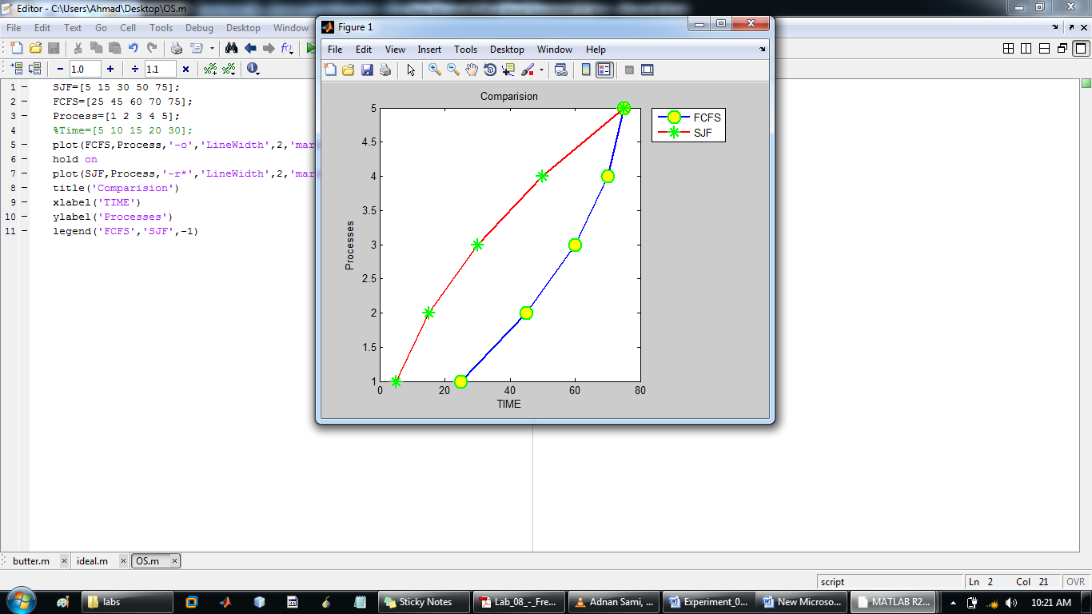

|  |  |  |  |  |  |
| --- | --- | --- | --- | --- | --- |
| **processes** | **P1** | **P2** | **P3** | **P4** | **P5** |
| **FCFS** | 25 | 45 | 60 | 70 | 75 |
| **SJF** | 5 | 15 | 30 | 50 | 75 |

Through put of all the processes at the will be same while it may be different in between. The total through put will be same at the end.

# AVERAGE WAIT TIME

|  |  |  |  |
| --- | --- | --- | --- |
| **Point** | | **Total Waiting Time** | **Average Waiting Time** |
| **Point 10** | **FCFS** | 100 | 25 |
| **SJF** | 68 | 13.6 |
| **Point 11** | **FCFS** | 175 | 35 |
| **SJF** | 175 | 35 |
| **Point 12** | **FCFS** | 275 | 55 |
| **SJF** | 175 | 35 |

# Conclusion

After examining the output of all the given codes by both of the methods i.e. FCFS and SJF I concluded that SJF algorithm is better than the FCFS because if we see in throughput comparison graphs we can clearly see that in SJF technique more number of processes complete in less time while in FCFS less number of processes complete in more time.

If we see average waiting time of all the given codes we can see clearly that in SJF algorithm the processes don’t have to wait more while in FCFS the average waiting time is usually more than SJF.

The input should be in ascending order of their Burst times because if a process of longer burst time comes first then rest of the processes have to wait for longer period of time while the situation will be opposite if the process with shorter burst time comes first.